Mid
Quiz by Attiq Kundi
SUBSCRIBE “Knowledge For Us” ON YOU TUBE 100 % CORRECT MCSQ

AND Many MoRe CS-101

- In binary Notation 11111111 is =
- 128
- 255
- 567
- 127
- What will be output of following OR expression 1010 OR 1111?
- 1111
- 0101
- 0000
- 1010
- Data were stored in memory program were part of the .
- CPU
- Cable
- BUS
- CACHE
- Which type of registers is used in program execution?
- General purpose
- CPU register
- Special purpose

- Memory address register
- Which of the following is used to store data in computer?
- Hard Disk
- Floppy Disk
- Optical Disk
- All of the Given
- UTF-8 Uses 24 to bits.
- 32
- 30
- 21
- 90
- To identify individual cells in a Computer’s main memory, each cell is assigned a unique “name” called its .
- Path
- Address
- Place holder
- Location
- The repetitive use of an instruction or sequence of instruction is called .
- Loop
- Statement
- Condition
- Pseudocode
- This finding maximum number function will keep on going until we reach at the last value [12,18,299,38,999,89,101,500,801,45]
- 45 each time
- 801 each time
- 12 each time
- 38 each time
- Dynamic ram-stores bits as tiny electric Charge.
- Refreshes no time a second

- Refreshes many times a second
- Refreshes one time a second
- Refreshes two time a second
- The Binary Search Algorithm, what will be the mid value in second level of recursion in the following array.
[45, 77, 89, 90, 94, 99,100] and key = 99
- 89
- 90
- 94
- 99
- Robots can be guided by an
- An external control device or the control may be embedded within
- An internal control device or the control may be embedded within
- Remote
- Application 13.Bit Is
- Basic unit of storage
- Basic program of storage
- Secondary unit of storage
- Not a unit of storage
- Which of the following language is used for server side scripting?
- HTML
- JavaScript
- CSS
- PHP
- Process states include the value of the program counter as well as the contents of the .
- Related memory cells
- Registers and related memory cells
- Registers

- Registers and cache memory cells

- How May iterations are required to find 88 in the following array? [5, 6, 77, 88, 99]
- 1
- 2
- 3
- 4
- 10.011 added to 100.11 produces
- 111.088
- 111.007
- 111.001
- 111.099
- The instruction code to halt machine cycle is
- C400
- C1000
- C000
- 35CE0

- Which Excess notation is used to represent 100 as Zero?
- Excess 4
- Excess 8
- Excess 2
- Excess 16
- Tag is used to write paragraph in HTML document.
- <p>
- <pr>
- <pa>
- <pg>

- Let a list Fred, Alex, Diana, Byron,Carol After sorted first sublist our list would be
- Alex, Fred, Diana, Byron, Carol
- Fred, Alex, Diana, Byron, Carol
- Alex, Diana, Fred, Byron, Carol
- Alex, Fred, Byron, Diana, Carol
- Which of the following is not true about pseudo code?
- Pseudo code is an unambiguous representation
- Pseudo code is an informal representation
- Pseudo code in an algorithms representation
- Pseudo code is an ambiguous representation
- Which of the following statement is true?
- Repeater is more complex than a bridge
- Bridge is more complex than a repeater
- Bridge and repeater both are complex
- Bridge and repeater both are not complex
- The storage of a value with a fractional part requires that we store not only the pattern of 0s and 1s representing its binary representation but also the position of the .
- Decimal Point
- Radix point
- Number
- Factorial
- Software packages that allow user to access hypertext on the internet are called .
- Hypersofts
- Browsers
- Linkers
- Routers
- is also consider as character.
- Numbers

- Small caps
- Large caps
- Space
- Word processor like Microsoft Word is an application that
- Build editable word documents
- Build editable Program
- Build editable Questions
- Build editable excel files
- Keyword is used in python language to define a word.
- Define
- Def
- Dfi
- Dfn
- Average amount of time required for the desired data to rotate around to the read/write head once the head has been positioned over the desired track.
- Random TIME
- Access time
- Seek time
- Rotational delay
- Appearance of each pixel is encoded to form .
- Pixel
- Geometric Structures
- Bitmap
- Scaling

- ────── is a package containing a party’s name and that party’s public key. a. certification
  - Antivirus
  - Security
  - Contract

- ────── refers to the address of a file (resource) accessible on the internet.

- Protocol
- Uniform Resource locator
- Web Browser
- HTML

- While sending a massage it is the ────── layers responsibility to provide an address that is compatible with the internet infrastructure.
- Application
- Network
- Link
- Transport

- If we have to insertion sort on name Fred Alex Diana Byron Carol one approach to sorting this list is to note that the sublist consisting of
- Both fred and Alex
- Only carol
- Only top name
- Sub list having 3 name

- A sequence of transactions in which the use establishes initial contact with a computer operating system is called────?
- Logout
- Process c. Login
d. Boot state

- Program counter is a──────.
- General purpose register
- Memory address register c. Special purpose register
d. Common purpose register

- Who have highly privileged access to the operating system?
- Admin or administrator
- Administrator or authorized user c. Super user or authorized user
d. Super user or administrator

- Bit is:
- Basic unit of storage
- Basic program of storage
- Secondary unit of storage

- Not a unit of storage

- Within a transfer category which instruction is used to communicating with device the CPU?
- STORE instruction
- COM instruction
- I/O instruction
- LOAD instruction

- CPU required at least───── to fetch the instruction form memory. a. Two nanosecond
- Nanosecond
- Three nanosecond
- One billion second

- Which loop structure refers as a pretest?
- While
- Do while c. For
d. For each

- Pseudo code is language──────.
- Dependent
- Independent c. Algorithm
d. Sequence

- Average amount of time required for the desired data to the read write head once the head has been positioned over the desired track.
- Random TIME
- Access time
- Seek time
- Rotation delay

- Who introduce the idea of storing the program in main memory?
a. John W. Mauchly b. John Von Neumann
c. J.presper Eckert
d. Konrad zuse

- The memory manager allocates─────.
a. Mass storage space b. Memory space
c. Space in the process table
d. Storage space

- What is the full form of ASP?
a. active start pages b. Active server page
c. Altemate server page
d. Altemate start pages

- When you search in the Google by typing Google find all those page which contain
- all the terms given in the query
- None of the terms given in the query c. Some of the terms given in the query
d. Random

- Which protocol is suitable for wireless star network? a. CSMA/CD
- CSMA/CA
- ETHERNET
- TCP/IP

- Which of the following is not the form of existing VoIP system? a. Soft phones
- Hard phones
- Analog telephone adapter
- Embedded VoIP phones.

- Three –dimensional interfaces allow human users to communicate with computer by means of.
a. 2D projection system b. 3D projection system
c. Dimensional system
d. Projection system

- GIF can obtain additional compression by using adaptive dictionary system which technique is used by adaptive dictionary system for this purpose?
a. Uniform length codes b. LZW techniques

c. Frequency dependent codes
d. Consecutive data units.

- Time required to move the read/write heads from one track to another.

- Random time
- Access time
- Seek time
- Rotational time

- Which of the following is the component name of iterative structures in which initial state is established.

- Modify
- Initialize c. Test
d. Declaration

- The execution of an algorithm must lead to……..

a. Start b. End
c. Cycle
d. Flow

- We need Memory to store data permanently.

- Volatile
- RAM
- Non-Volatile
- Address

  - In analysis of algorithms ⎯⎯⎯⎯generally measured in term of the number of steps required to execute an algorithm
    - Bandwidth b) Time
- Memory

- Logical functions

  - An anchor tag consists of two parts: action and label.<a href=”http://www.vu.edu.pk”>virtual university!</a> in above example, which of the following is action part?
    - Virtual university!
    - HTTP
    - www.vu.edu.pk d) HREF

  - ⎯⎯⎯⎯ help in finding synonyms as well as antonyms in word processors
    - Tables
    - Thesaurus
    - Spilling & Grammar
    - Word count

  - Grammar and spell accuracy can be increased with the help of ⎯⎯⎯⎯in word processor.
    - Word count
    - Table Auto Format
    - Spell and grammar checker
    - Text box

  - Attribute/attributes of the good application software is/are:
    - Easy to install
    - User interface
    - Consistent
    - All of the above

  - If a computer could pass the Turing test then it would test then it would be able to:
    - Win a million dollar prize
    - Think like human beings
    - Think but slower than humans
    - Do the things faster

  - ⎯⎯⎯⎯⎯ Contains the name of the protocol required to access the resource, a domain name that identifies a specific computer on the internet and a pathname on the computer.
    - HTML
    - HTTP
    - WWW d) URL

  - VGA port is use to connect ― device
    - Input
    - Monitor
    - Modem
    - No of above

  - What will replace transistors?
    - Electo-machanical computing
    - Vacuum tube computing c) Quantum computing
d) Nothing can replace transistors

  - VULMS is an example of ― software
    - Engineering
    - Entertainment c) Educational
d) Assume Scientific
  - Assume that you are developing washing machine. In your opinion. Which operating system will be better to fulfill requirements of a washing machine?
    - Multi user operating system b) Real time operating
- Distributed operating system
- None of the above

- Which one of the following operating system has highest security?
  - Windows
  - Linux c) Unix
d) Mac

- Analytical engine was a computer for
  - Scientific use
  - Micro processing
  - Embedded device d) General purpose

- Which one of these is not an example of storage device?
  - CD
  - Floppy

  - Hard disk d) RAM

- An HTML document is development is developed in a plain-text editor called ⎯⎯⎯.
  - Note Pen
  - Notepad
  - Text pad
  - Editor

- Loop in flow chart or pseudo code means
  - A set of instruction to be executed if a specific condition is true
  - A set of steps to be performed at once if a specific condition is true c) A set of step to be repeated as far as a specific condition remain true
d) Terming the program as soon as loop is encountered

- The word first communication network was:
  - WAN
  - APPANET
  - Intranet
  - LAN

- Digital computer possess two natural states⎯⎯⎯⎯and⎯⎯⎯
  - On& on b) On & off
- Off & off
- None

- Microcontroller is used to control⎯⎯⎯ a) Electronic equipment
- Mechanical equipment
- Electro-mechanical equipment
- None of above

- Which of the following is a computer storage device that saves and retrieves the data when required? a) Hard disk
- RAM
- ROM
- None of the given choices

a) Numeric value b) A URL
- A test value
- None of above

- An anchor tag consist of two part: action and label.
<a href,”http: //www.vu.edu.pk”>virtual university! </a> In above example, which of the following is action part?

  - Virtual university
  - HTTP
  - www.vu.edu.pk
  - HREF

- If a computer cloud pass the turning test then it would be able to:
  - Win a million dollar prize b) Think like human beings
- Think but slower than humans
- Do the thing faster

- Disk operating system is ⎯⎯⎯operating system
  - Menu drive
  - Graphical user interface c) Command driven
d) None of the given

- Punched card were replaced by: a) Floppy disk
- Zip drives
- Magnetic storage
- None of the given choices

- In this URL http://www.msn.com, what identifies the domain name?
  - http
  - www
  - msn d) com

a specific computer on the internet and a pathname on the computer.
- HTML
- HTTP
- WWW d) URL

- You Need to Place University Name On top of the every page of 100 pages document and page. This can be down with the help of ⎯⎯⎯⎯
  - Reference initials
  - Bullet and numbering
  - Borders and shading d) Header and footer

  - parallel port is use to connect a ⎯⎯⎯
    - Speakers b) Printer
- Mouse
- Keyboard

- Which one of these is NOT an example of embedded computers
  - Microwave oven b) IMB PC
- Refrigerator
- Calculator

- Vacuum tubes were replaced by: a) Transistors
- Electrodes
- Electric relays
- None of the given choices

- Algorithm is a sequence of steps that can be taken to solve a given ⎯⎯⎯⎯
  - Task
  - Process c) Problem
d) All of given

  - date cell of a table contain
    - Only text

    - Images
    - Tables
    - All of the given

- To select multiple options in a list we use ⎯⎯⎯⎯control
  - Radio button b) Check box
- Selection list
- Ordered list

compact disk is consist of material:

Reflectiv e
Digital versatile disk | capacity is MB  600 to700
SSDs stand for........
solid state disk
ASCII codes have combinations
27
Unicode’s have a unique pattern of bits.
21
MIDI stands for.........
musical instrument t digital interface

Integer representation in 2's complement used normally
32
.......bits

When data being compressed consist of long sequence of
Run length

......same value, the compression technique is called
Encoding
SDHC (high capacity) can provide. GBs
32

Mostly computers have additional storage devices
Mass storage
called.......

Most computers have additional memory device called
DVD,s an flash

mass storage is
driv e

When you want to search Google or search a query on a
d):"@ "
particular social media, you can add a symbol?

Fact sheet of ENIAC having weight
30
tons

Example of search engine is -----------------
Google, Yahoo
and MSN

The rate at which data transfer to or from disk
transfer rate

Computer hardware is the collection of ….. of computer
Ph
ysical parts
system

A machine especially one programmer by a computer are
Robot s called

Computer science applications are…………

7

---------Data base learn about will be implemented using

DBMS
-- tool like Microsoft access

-----------------One of the earlier computer device was the
Abacus
d

s
--
1 kilo byte is equal to

- ---------------------
1024 byte
1 tear byte is equal to

-----------
1024 GB
--------In one bit we can represent two pattern
0 or 1

24 The bit receiver is known as the machine
Main memory
Random access
memor y
Transfer rate
Blue ray disk Computer
added
desig n
More
Main memory

25 RAM access for ----------------

Random access

26 The rate at which can be transferred to or from the disk
memory Transfer rate rate

27 BDs stand for -----------------------
Blue ray disk

28 CAD stand for -------------
Computer
added
desig n

- Loosy techniques compression than
can often provide than --------
lossless

Adaptiv

- A variation of dictionary encoding is ------------------

- is storage organization in which are ordered in
FIFO fashion

- Techniques that allow the steps in the machine cycle to overlap

- MP3 do not require transfer rate more than....

- successfully relayed on communication paths having 40 Mbps
e
dictionar y
encodin g
Queu e

Pipelinin g

64
Kbps
MPE G

 |  | Transfer rate.
35 |  | CPU and main memory connected via........ |  | Bu s
36 |  | MP3 is short for..... |  | MPEG layer 3
37 |  | The best known system for compressing audio is...... |  | MP 3
38 |  | The idea of storing a computer's programme in its main |  | Stored program
 |  | memory is called....... |  | concep t
39 |  | CPU is designed to recognise institutions encoded as |  | Bit patterns
40 |  | Collection of instructions along with the encoding system |  | Machin e
 |  | is called |  | languag e
41 |  | RISC stands for |  | Reduce d
 |  |  |  | instructions set
 |  |  |  | computer
42 |  | A request to transfer the contents of a register to a |  | STOR E
 |  | memory cell is called........ |  | instructions
43 |  | The commonly used standards for encoding and |  | MPE G
 |  | compressing audio and video were developed:
44 |  | CPU consists parts: |  | 3
45 |  | The use of AND operation is an example of the |  | Maskin g
 |  | process……..:
46 |  | 8Kbps=…………: |  | 1KB per second
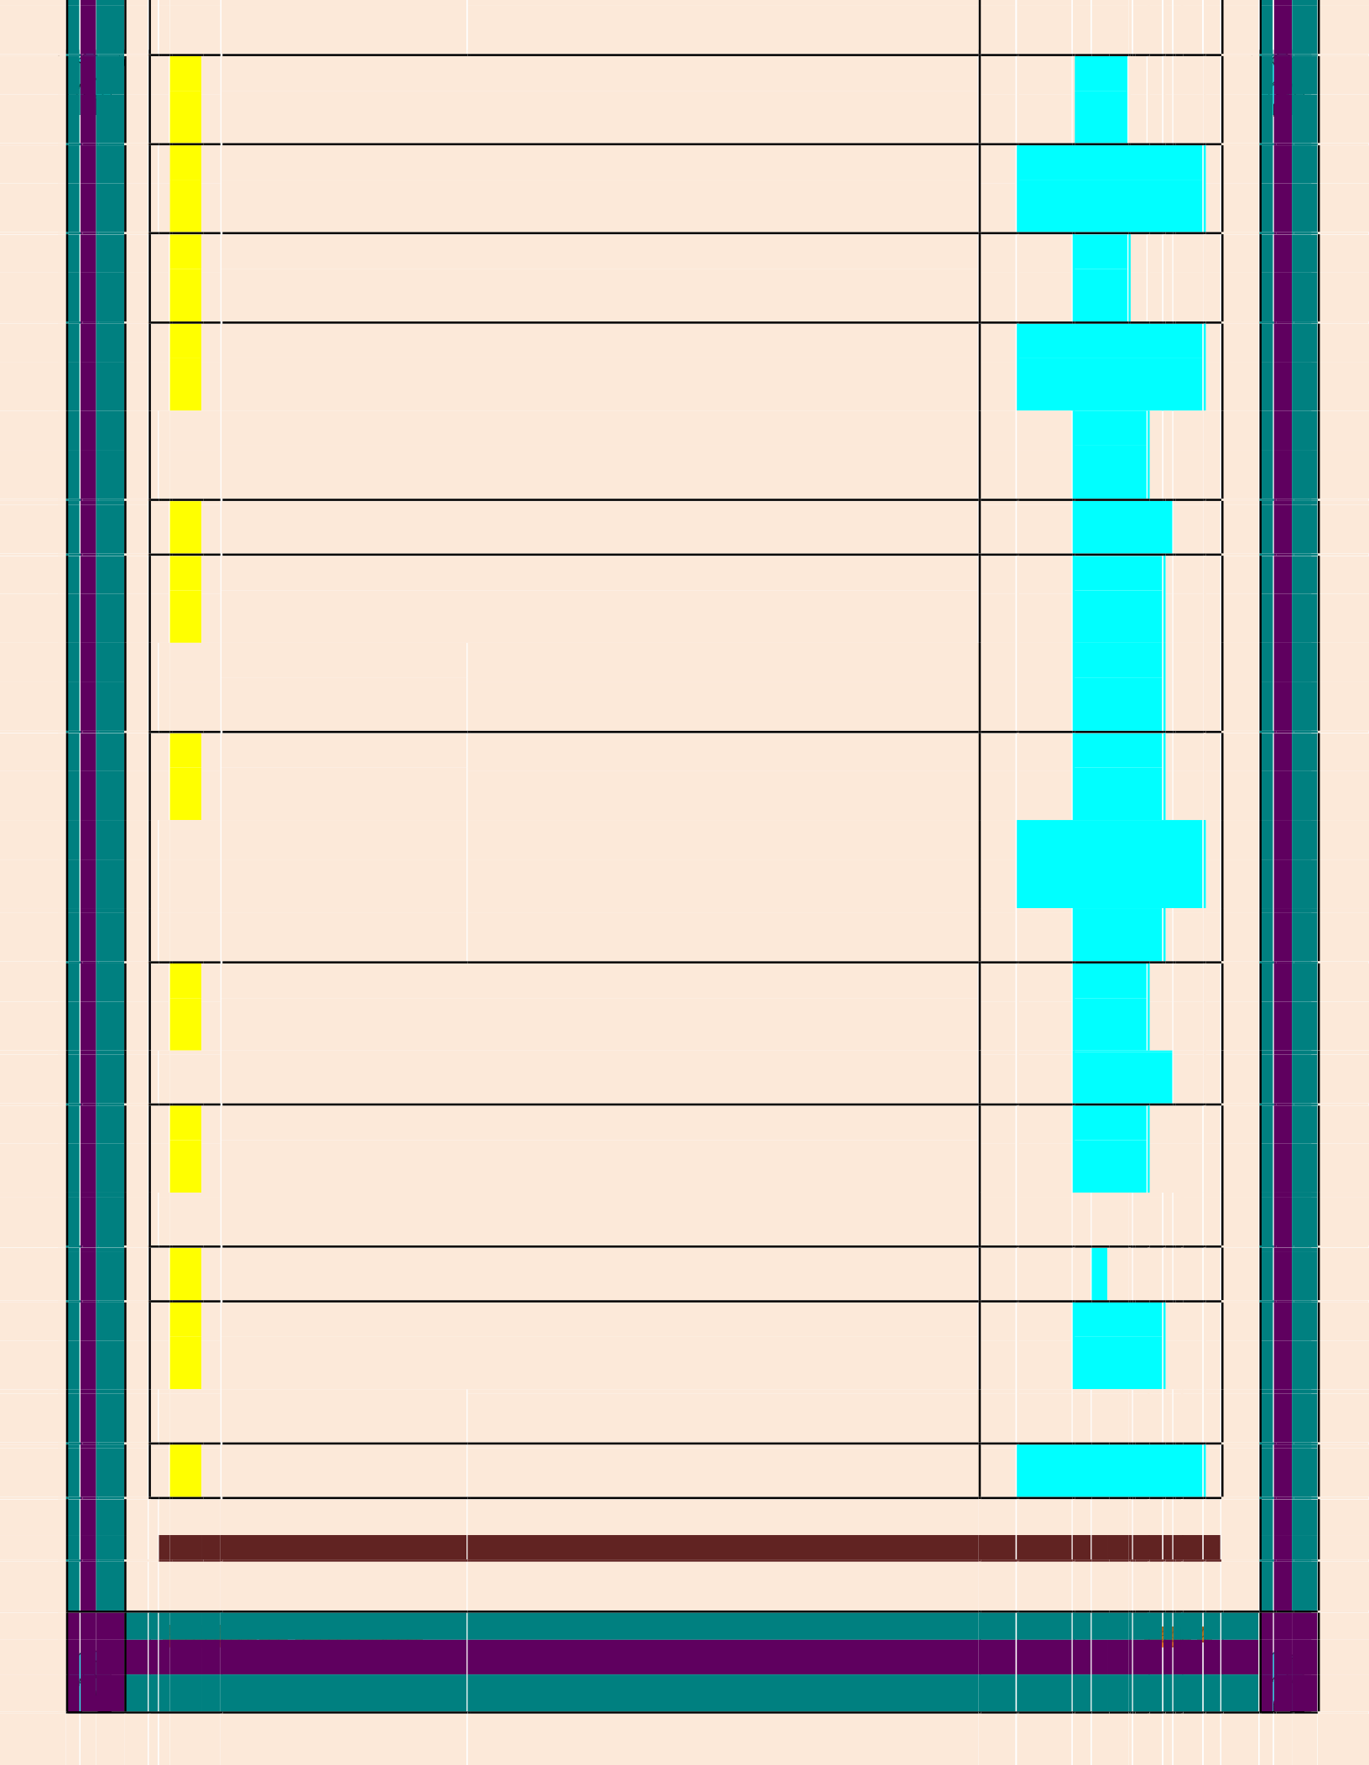

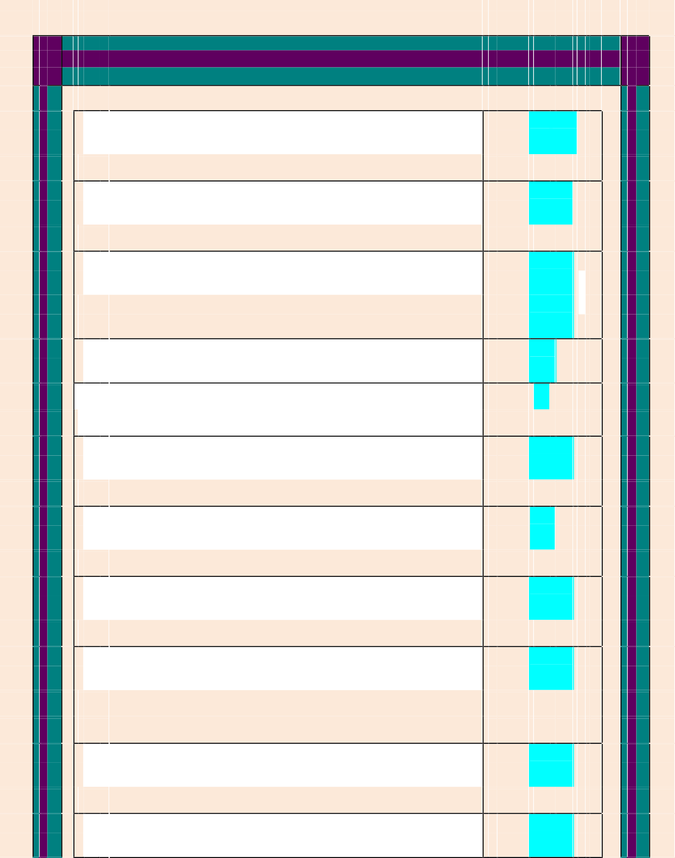

 | 47 |  | Communication between computer and other device is |  |  | Controlle r
 |  |  | handling through apparatus called……:
 | 48 |  | The ability of a controller to access main memory |  |  | DM A
 |  |  | called…..:
 | 49 |  | WAN is abbreviated of ……..: |  |  | wide wire
 |  |  |  |  |  | networ k
 | 50 |  | The best known system of compressing audio is....... |  |  | mp 3
 | 51 |  | Mp3recording generally require transfer rates of no more |  |  | 64
 |  |  | than kbps.
 | 52 |  | To compare sequence of picture in MPEG only some of |  |  | I –  frame
 |  |  | the pictures called
 | 53 |  | A machine CPU and main memory are connected by a |  |  | Bu s
 |  |  | collection of wires called?
 | 54 |  | The idea of storing a computer’s program in its main |  |  | Store data
 |  |  | memory is called?
 | 55 |  | The now decode the content of its instruction register and |  |  | 5 and  6
 |  |  | executes its by activating the two’s complement addition
 |  |  | circulatory with inpits being register?
 | 56 |  | The use of AND operation example of the process called |  |  | Maskin g
 |  |  | ?
 | 57 |  | The result of circular shift is called? |  |  | Rotatio n

58 |  | Usb and Fire wire provide several? | Hundred Mbps
59 |  | Communication between computing device is handled | Serial and
 |  | over path? | paralle l
 |  |  | communicatio n
60 |  | GbPS is? | Billion Bits
61 |  | The portion of an operating system that handles this | :user interface
 |  | communication is often called the
62 |  | Most file manager allow files to be grouped into a bundle | :folde r
 |  | called
63 |  | A chain of directories within directions called path | Director y
64 |  | Components of an operating system's kernel is the | memor y
 |  |  | manage r
65 |  | The memory manger reserves of storage space on a | 4G B
 |  | magnetic disk
66 |  | Rom stands for | Read only
 |  |  | memor y
67 |  | Culprit that auditing systems are designed to detect in the | sniffing software
 |  | presence
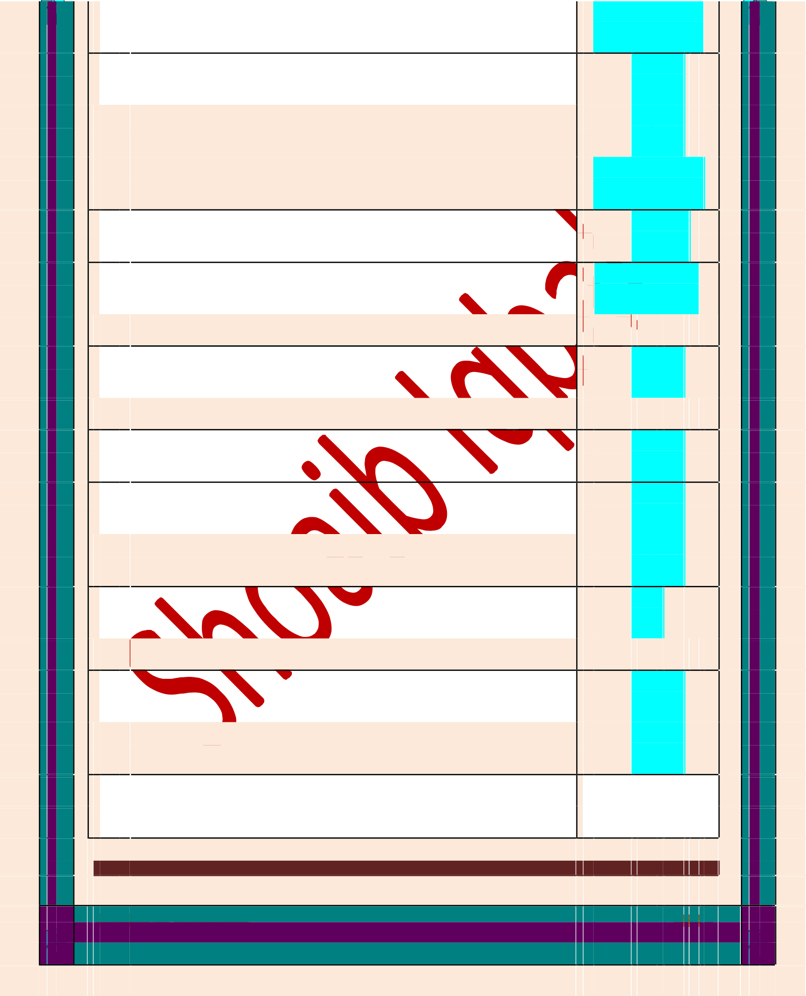



 | 68 |  | A network of former type is called network |  |  | Ope n
 | 69 |  | Computer network is often classified as: |  |  | All of these
 | 70 |  | The technique of holding data for output at a later but |  |  | Spoolin g
 |  |  | more convenient time is called
 | 71 |  | A technique that transfer the distribution problem to |  |  | Multi cast
 |  |  | internet routes --
 | 72 |  | A programme that enter a computer system disguised as |  |  | Trojan horse
 |  |  | a desirable programmed -----------
 | 73 |  | Transporting audio and video across the internet in real |  |  | Streamin g
 |  |  | time is known as
 | 74 |  | If a user is using CGI script on a UNIX server, then the |  |  | server side
 |  |  | script type is called........ |  |  | scriptin g
 | 75 |  | XML stands for |  |  | Extensibl e
 |  |  |  |  | ma lan | rkup guage
 | 76 |  | OSI stands for |  |  | Open system
 |  |  |  |  |  | interconnectio n
 | 77 |  | 3… Is a software that infects a computer by inserting |  |  | Viru s
 |  |  | itself into programs that already reside in the machine
 | 78 |  | ….is an autonomous program that transfers itself through |  |  | Wor

 |  |  |  |  | m
 |  |  | a network, taking up residence in computer and
 |  |  | forwarding copies of itself to other computer.
 | 79 |  | Another form of malicious software is |  | Spywar e
 | 80 |  | Dos stands for |  | Denial of service
 | 81 |  | Problem associated with an abundance of unwanted |  | Spa m
 |  |  | messages is the proliferation of unwanted email called.
 | 82 |  | Prevention tool that has filtering connotation is the….. |  | Proxy server
 | 83 |  | SSL stands for |  | Secure socket
 |  |  |  |  | laye r
 | 84 |  | Public key is used for ………messages |  | Encryp t
 | 85 |  | Virus is executed in a computer |  | Before execution
 |  |  |  |  | of Host
 | 86 |  | Explosion of replicated copies that degrade the |  | .  Worm
 |  |  | performance of legtimate application. This is property of
 | 87 |  | Trojan can enter |  | through games
 |  |  |  |  | and utility
 |  |  |  |  | packag e
 | 88 |  | Spyware also called |  | Sniffing software
 | 89 |  | Process of overloading a computer with messages. |  | Do S
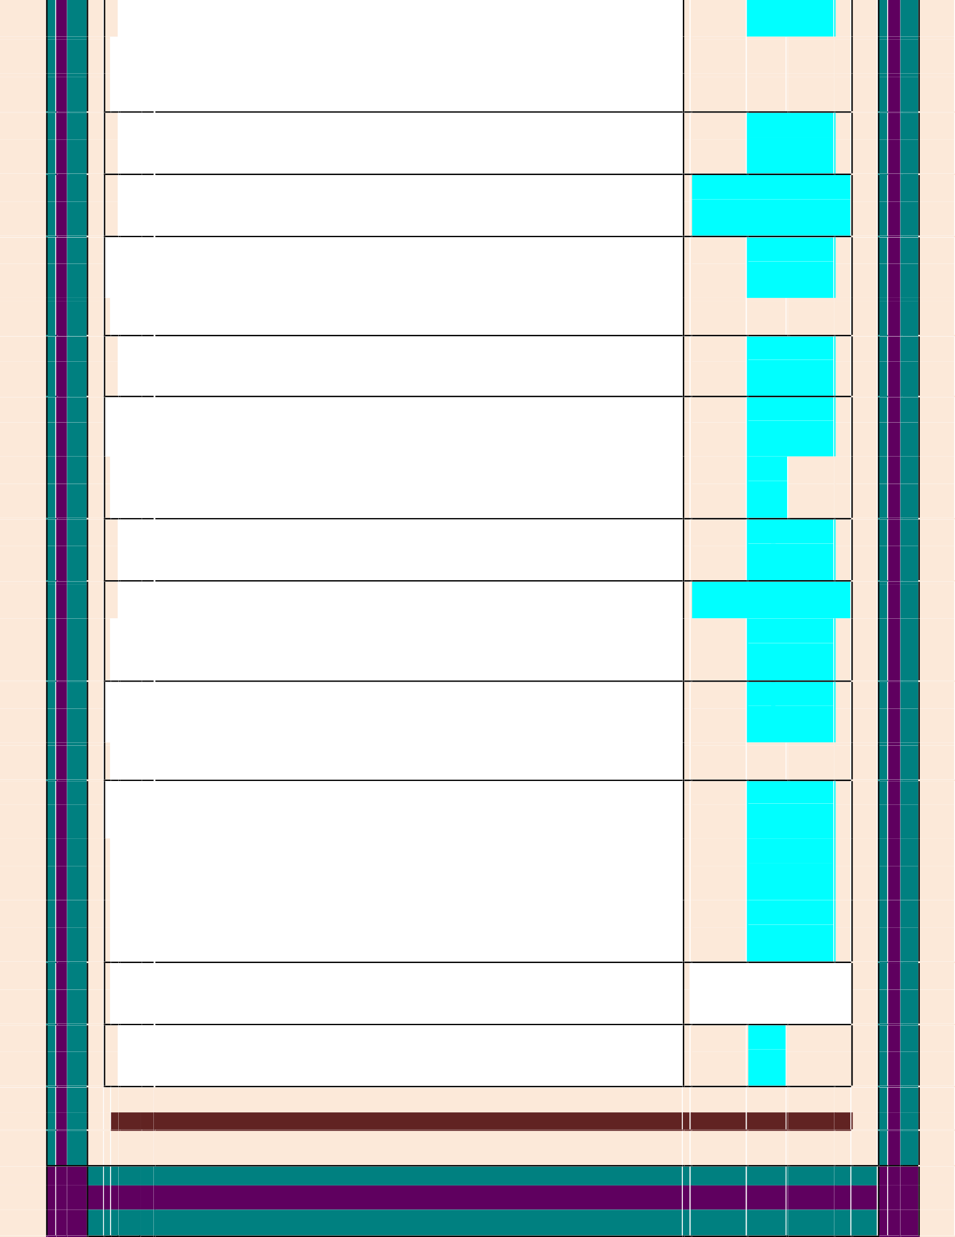



90 | Software that act as a shield to protection from adverse |  | proxy server
 | actions
91 | Spam filter can distinguish between desired mail and |  | True
 | spam
92 | Which key is required to decrypt messages |  | private key
93 | Computer Fraud and abuse act Cover |  | Theft of
 |  |  | Information and
 |  |  | worms and
 |  |  | viruses
94 | Repeaters passes signals between |  | Two original
 |  |  | buses
95 | A bridge is similar to a |  | Repeater
96 | Peer-to-peer often abbreviated as |  | P2P
97 | service allow clients to rent virtual |  | Amazon’s
 | computers by the |  | Elastic Compute
 | hour, without concern for where the computer hardware is |  | Cloud
 | actually located.
98 | The distinction between the tier-1 and tier-2 ISPs is often |  | True
 | a matter of opinion.
99 | An access ISP is essentially an independent internet, |  | Intranet
 | sometimes called
10  0 | The process of using DNS to perform a translation is |  | DNS  Lookup
 | called
10  1 | VoIP is the abbreviation of |  | Voice over

 |  |  |  |  | Internet Protocol
 | 10  2 | An enormous portion of current internet traffic is used for |  |  | Streaming
 |  | transporting audio and video across the internet in real
 |  | time, is known as
 | 10  3 | WWW is the abbreviation of World Wide Web |  |  | True
 | 10  4 | A networking technology called , which |  |  | Anycast
 |  | enables an end user to automatically connect to the closest
 |  | server out of a defined group of servers helps to make
 |  | CDNs practical
 | 10  5 | A second form of VoIP consists of |  |  | Analog
 |  |  |  |  | Telephone
 |  |  |  |  | Adapters
 | 10  6 | The point at which one network is linked to an internet is |  |  | Gateway
 |  | offen called
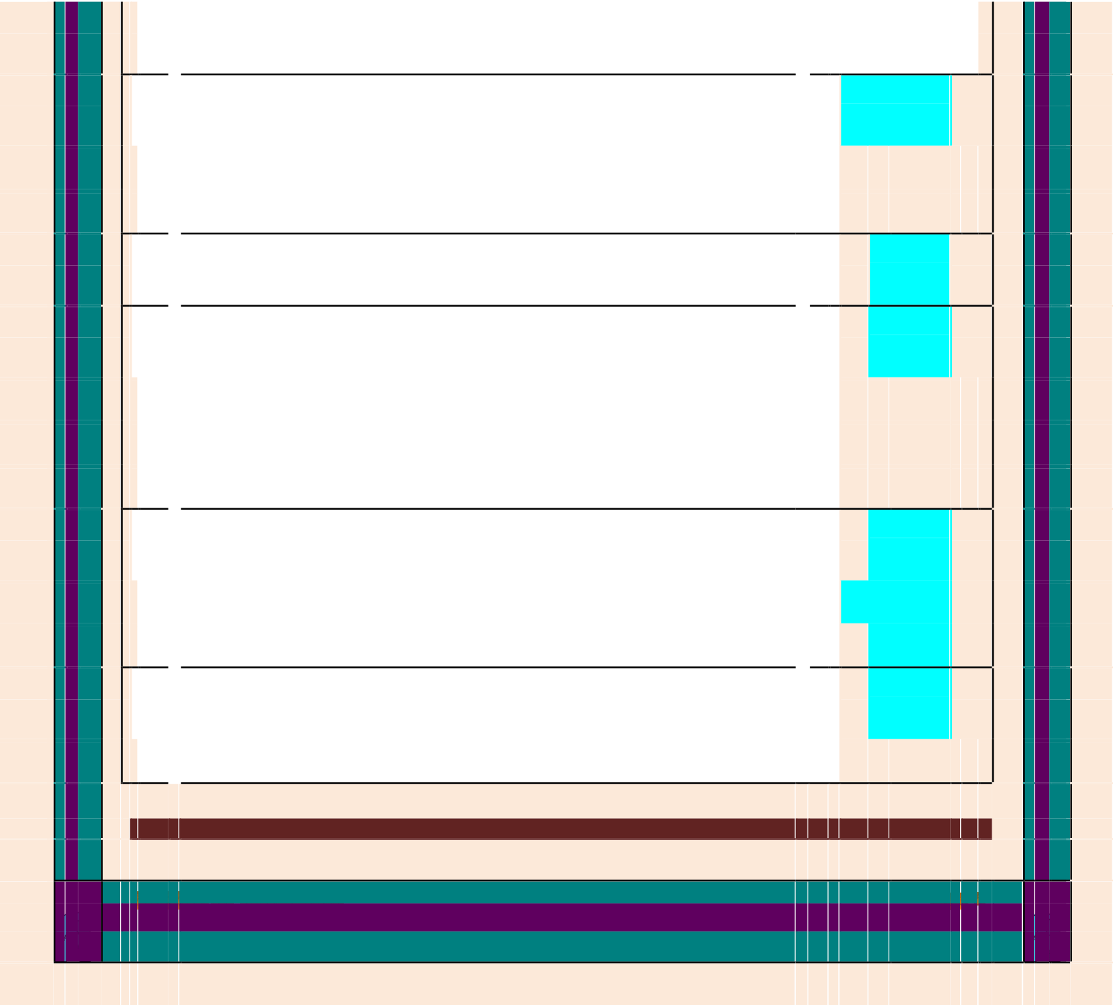

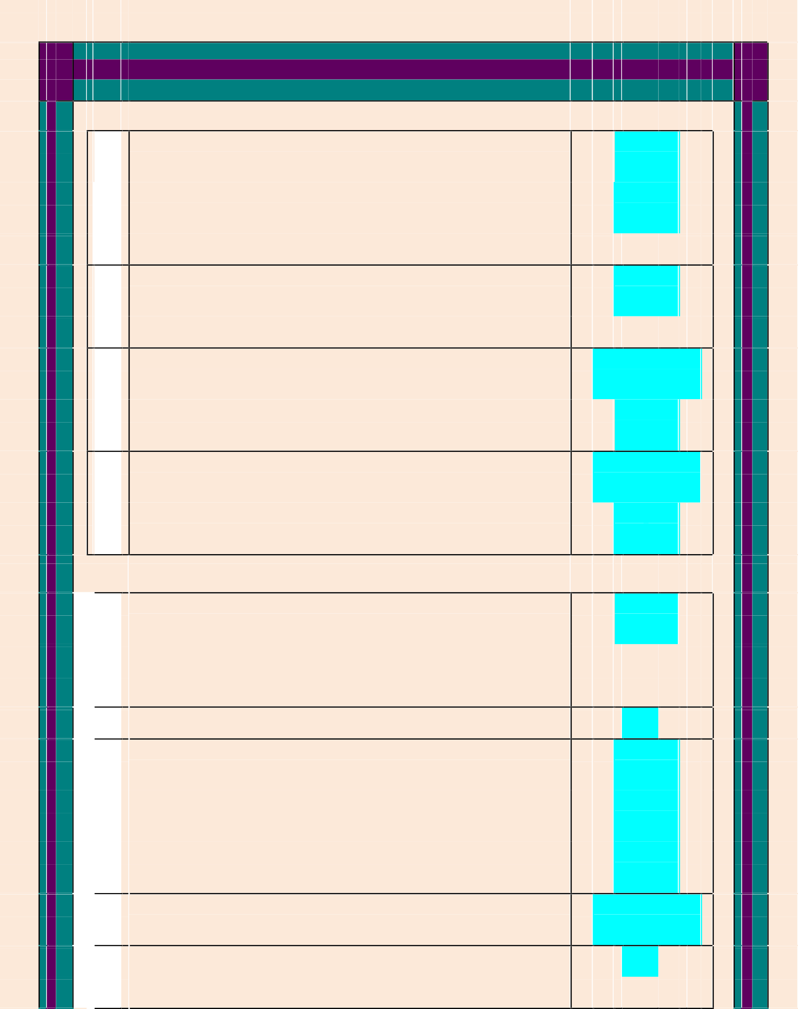

 | 107 |  | Distributed system in which many independed computer |  | Cluste r
 |  |  | work closely to gether to provide computation or service |  | computin g
 |  |  | comparable to a mach larger machine?
 | 108 |  | Each domain must be registerd with ICANN process |  | Registrar s
 |  |  | handled by companies called?
 | 109 |  | DNS mean? |  | Domain name
 |  |  |  |  | Syste m
 | 110 |  | Softwere packages that allow users to access hypertext on |  | Browsers and
 |  |  | the internet fall into categories? |  | Webserve r
 | 111 |  | Essentially a notational system by which a text document |  | HTM L
 |  |  | along with the document’s appearance can be encoded as
 |  |  | a simple text file
 | 112 |  | Hypertext document also contain special symbol called? |  | Tags
 | 113 |  | URL means? |  | Unifor m
 |  |  |  |  | Resourc e
 |  |  |  |  | Locato r
 | 114 |  | Common Internet brewers include..... |  | Firefox, safari
 | 115 |  | The distinction is that a hypertext document also contains |  | Tags
 |  |  | special symbol..

116 | A traditional hypertext document is similar text file |  | source version
 | because text is HTML - encoded...
117 | HTM is essentially a notional system by which text |  | simple text file
 | document's...
118 | )Music is traditionaly reperseted does not conform the |  | text file
 | character by character..
119 | The additional activity by either the browser or the web |  | client side
 | browser..
120 | Then it hands these segment known .. |  | Packet s
121 | OSI standard for ...... |  | Open system
 |  |  | interconnection s
122 | Origin perpare a packet it appends a value called .. |  | hop count
123 | If two functins were performed 'PROCESS LOAN' AND ' |  | If-else method
 | REJECT APPRECIATION' what should be structure of
 | problem
124 | What should be sequenc |  | Problem- devise
 |  |  | plan-carry plane
125 | Stepwise refinement is a strategy to conquere at once |  | Task
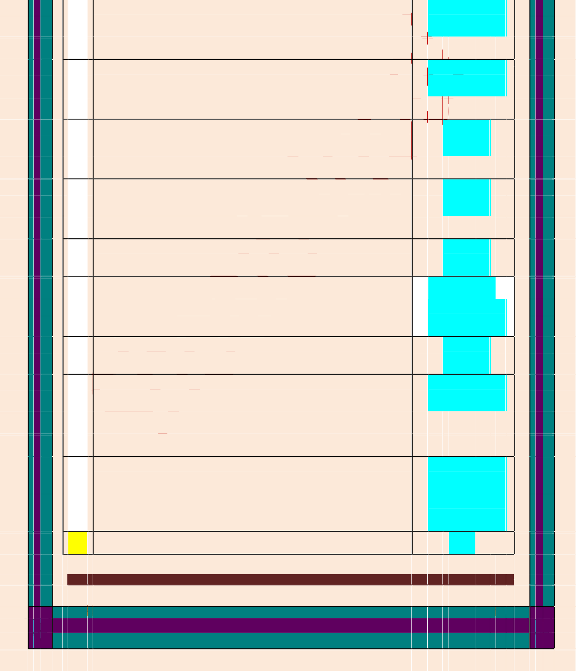

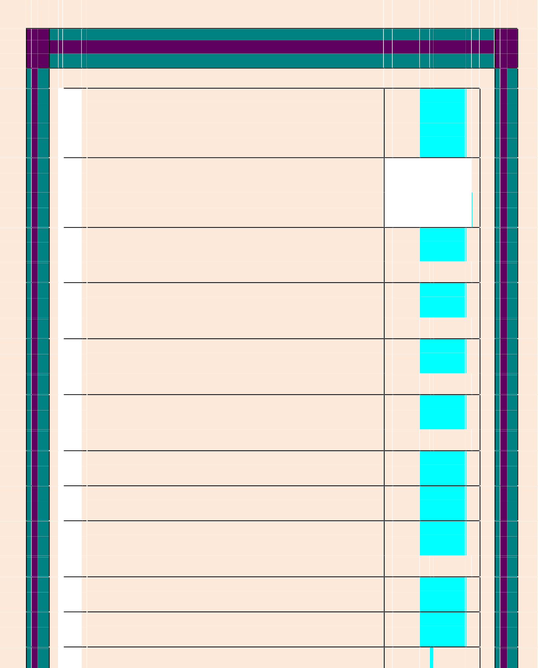

126 |  | Which strategy is contrast to stepwise refinement |  | Bottom- up
 |  |  |  | methodolog y
127 |  | Which has cause Computer science to grow so much |  | Algorithms and
 |  |  |  | problem solving
128 |  | As a general rule the use of a loop structure produces........ |  | higher degree
 |  | Of flexibility
129 |  | A method of implementing repitition is the iterative |  | Loo p
 |  | structure knows as
130 |  | Change the state in such a way that it moves towards the |  | Modif y
 |  | termination condition
131 |  | In each iteration "i" the current value of "i" will........ |  | Multiplie d
 |  | With current value of "f"
132 |  | The control of a loop consist of how many activities |  | Thre e
133 |  | Repeat loop structure referred to as a |  | posttest loop
134 |  | If we reach the end of the list without finding the target |  | Failur e
 |  | value our search terminates as....
135 |  | In which collection of instructions called... |  | body of loop
136 |  | Write a for finding maximum number from a list. |  | pseudo- code
137 |  | The loop will keep executing until remains smaller |  | I

 |  |  | or equal to n.
 | 138 |  | Set of steps that define how a task is performed is called |  |  | Algorith m
 | 139 |  | In Unambiguous, the information in the state of the |  |  | Tru e
 |  |  | process must be sufficient to determine uniquely and
 |  |  | completely the actions required by each step.
 | 140 |  | A single algorithm can be represented in |  |  | Many ways
 | 141 |  | The sentence, could mean either that |  |  | “Visitin g
 |  |  | the grandchildren cause problems when they come to visit |  |  | grandchildre n
 |  |  | or that going to see them is problematic. |  |  | can be nerve
 |  |  |  |  |  | racking ”
 | 142 |  | One semantic structure is the of a computed |  |  | Savin g
 |  |  | value.
 | 143 |  | Another common semantic structure is no any repeation |  |  | Tru e
 |  |  | execution of a statement or sequence of statements as
 |  |  | long as some condition remains true.
 | 134 |  | In a man in Texas received very high radiations. |  |  | 198  6
 | 135 |  | Which is not the advantage of software verification |  |  | Non e


ComAplulteSrocalnveexdecMuteC..Q....S.ofWinsittrhucRtioenfseiirneansceceosndIn One FiBliell.ions
136
137

A measure of the execution time necessary for an algorithm to complete work in a set of
In general a recursive function is designed to test for the termination condition often called
138

One method of implementing such repetition is the iterative structure known as:
139
In which execution of function the tested condition we're true. ??
140
select the entry in the list known as: A methodology progresses from the specific to the
141
142
general :
the collection of instructions called??
143
144
the loosely defined problem solving phases presented by the mathematicians G.polya in ??
Test for termination is performed before the body is executed in pretest loop:
145
In insertion sort Algorithms lists are sorted out into: IF our target value is not present in oriental list, our
1
147
146
Data

Base or degenerative case
Loop

process loan

test entry bottom up

Body 1945

True

alphabetical order
By dividing into

e File.
 | appArolalchStoo lsveaerdchMwiCll QprSocWeediatsh: References In O | nsmaller segments
148 | Binary search executes each stage of a repetition as a  subtask of the previous stage, known as: | Recursion
149 | A recursive function is designed to test for: |  |  | Degenerative
149 | A recursive function is designed to test for: |  |  | and base case
149 | A recursive function is designed to test for: | and termination
149 | A recursive function is designed to test for: |  | condition (All)

BEST OF LUCK AND JAZAK ALLAH FOR ALL THOSE MEMBERS WHO

COPERATE WITH ME AND GROUP ADMINS

All Solved MCQS With References In One File.

All Solved MCQS With References In One File.


Spring 2010
CS101- Introduction to Computing

All Solved MCQS With References In One File.

Question No: 1 ( Marks: 1 ) - Please choose one

Vacuum tubes were replaced by _

- Punch cards

Transistors

- Micro Processors

- Resistors

Page 14 .Prior to the transistor the only alternative to its current regulation and switching functions (TRANSfer resISTOR) was the vacuum tubes

Question No: 2 ( Marks: 1 ) - Please choose one

Hexadecimal number system is based on digits

- 2

- 8

- 12

- 16

All Solved MCQS With References In One File.

Question No: 3 ( Marks: 1 ) - Please choose one

Java script interact with user through

- Special control

Internet explorer

- Event handlers

- Java script does not interact with user

The most compelling reason people have to use JavaScript for web pages are to allow

interaction with users.

http://www.bellaonline.com/articles/art39576.asp

Question No: 4 ( Marks: 1 ) - Please choose one

Which one is correct for JavaScript?

onMouseOver

- OnMouseOver

- AonlmloSusoeolvveer d MCQS With References In One File.

- All of the given

JavaScript understands onMouseOver – it is one of the pre-defined keywords in JavaScript

Page 97:

Question No: 5 ( Marks: 1 ) - Please choose one

Programs that reside on Web servers and receive info that a user enters in a form, are known as:

Server-Side Scripts

- Client-Side Scripts

- Super Scripts

- Form Scripts

Page 94: Are programs that reside on Web servers Receive info that a user enters in a form
Process that info and take appropriate action Examples:
CGI scripts on UNIX servers ASP scripts on Windows servers

Question No: 8 ( Marks: 1 ) - Please choose one

The _ is connected to all other modules of the microprocessor.

Control unit

- Memory unit

- Floating Point unit

- Arithmetic and Logic unit

Page 36: A control unit is the part of a CPU or other device that directs its operation. The outputs of the unit control the activity of the rest of the device. A control unit can be thought of as a finite state machine.

Question No: 7 ( Marks: 1 ) - Please choose one

WWW stands for:

- Wide World Web

World Wide Web

- World White Web

- World Web Wide http://in.answers.yahoo.com/question/index?qid=20061023005113AALDWvC

Question No: 8 ( Marks: 1 ) - Please choose one

Supercomputers are used in:

- Weather forecasting

- Aeroplane mnufacturing

- Atomic bomb experiments

- All of the given choices http://mason.gmu.edu/~tbell5/page5.html

Question No: 9 ( Marks: 1 ) - Please choose one

Which one of these is NOT an example of storage devices?

- Tape

RAM

- Floppy

- DVD

Page 25:

Question No: 10 ( Marks: 1 ) - Please choose one

To display a checkbox on the web page, we use tag

ACHlElCSKBoOlXved MCQS With References In One File.

All Solved MCQS With References In One File.
- CHECK

INPUT

- INPUTBOX

Page 92:
Possible Values for the “type” Attribute of <INPUT> tag text Password hidden checkbox radio file reset submit

Question No: 11 ( Marks: 1 ) - Please choose one

Users communicate with the computer using a consistent user interface provided by the OS.

True

- False

A user interface is the system by which people (users) interact with a machine.

http://en.wikipedia.org/wiki/User_interface

Question No: 12 ( Marks: 1 ) - Please choose one

OO software is all about .

ABelhlavSioorslved MCQS With References In One File.

- Methods

- Properties

Objects

Object-oriented programming (OOP) is a programming paradigm using "objects"

http://en.wikipedia.org/wiki/Object-oriented_programming

Question No: 13 ( Marks: 1 ) - Please choose one

Web standards are being developed by

- Mozilla

- Microsoft

- IBM

World Wide Web Consortium Page 16:

Question No: 14 ( Marks: 1 ) - Please choose one

are great for showing parts of a whole that are generally expressed in percentages.

  - Line Charts

Pie Charts

  - Bar Charts

  - None of the options described

Page 154:

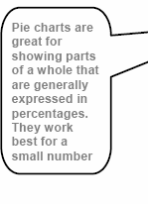

Question No: 15 ( Marks: 1 ) - Please choose one

A diode is a _terminal device

- Three

Two

- One

- None of above

Page 32: The basis of all semiconductor components is the pn junction.

http://electroniccircuitsforbeginners.blogspot.com/2010/11/diode-most-basic- semiconductor-device.html

Question No: 16 ( Marks: 1 ) - Please choose one

Select the attribute of the <form> tag

- Method

- Action

- Value

All of above Page 74:

Review of the Tags Used in Forms

_{<FORM>}All Solved MCQS With References In One File.

name=“nameOfTheForm”

All Solved MCQS With References In One File.

method=“get” or “post” action=“URL”

MIDTERM EXAMINATION
Fall 2008

CS101- Introduction to Computing (Session - 2)

Question No: 1 ( Marks: 1 ) - Please choose one
consists of cells arranged in rows & columns

_ Spreadsheets Software
_ Word processor
_ Presentation Software
_ Microsoft Paint Software

Page 83:
13.17 Spreadsheet SW (2)
Consist of cells arranged in rows and columns

Question No: 2 ( Marks: 1 ) - Please choose one
manages the HW and SW resources ( memory, disk drives etc) of the computer
system, often invisibly.
_ Explorer.exe
_ System Files

_ Operating System
_ Application Software

page 61:

Question No: 3 ( Marks: 1 ) - Please choose one
Forms can be submitted through _ & _ methods

_ INCLAUDlEl ,SPoOlSvTed MCQS With References In One File.
_ INCLUDE, GET
_ GET, POST

_ SEND, POST

Question No: 4 ( Marks: 1 ) - Please choose one
To display a checkbox on the web page, we use tag
_ CHECKBOX
_ CHECK

_ INPUT
_ INPUTBOX

Repeated:
Page 92:
Possible Values for the “type” Attribute of <INPUT> tag text
password hidden checkbox radio
file reset submit

Question No: 5 ( Marks: 1 ) - Please choose one You
can _ from/to a website containing interactive forms.
_ Only read
_ Only write
_ Read and write
_ Not read and write
Question No: 6 ( Marks: 1 ) - Please choose one There is a battery on the motherboard to:
_ Give power to the processor

_ Save information when computer is off
_ Save information when computer is on
_ Give power to the motherboard

http://www.kids-online.net/learn/clickjr/details/bat.html
The motherboard battery is used to preserve the computer's time and BIOS settings while the computer is turned off.

Question No: 7 ( Marks: 1 ) - Please choose one We
can change the background color in HTML, using _ attribute of <body>

_ background

_ bgcolor
_ backcolor
_ backgroundcolor

Page 125:

Question No: 8 ( Marks: 1 ) - Please choose one

contains the name of the protocol required to access the resource, a domain name that identifies a
specific computer on the internet and a pathname on the computer
_ HTML
_ HTTP
_ URL

_ WWW
Page 16:

Question No: 9 ( Marks: 1 ) - Please choose one
_ is a client program that uses HTTP to make requests to Web servers throughout the
internet on behalf of the user.
_ Web Application

_ Web Browser
_ Internet Application
_ HTML

See the Lecture 3:

Question No: 10 ( Marks: 1 ) - Please choose one WWW stands for:
_ Wide World Web

_ World Wide Web
_ World White Web
_ World Web Wide

page 18:

Question No: 11 ( Marks: 1 ) - Please choose one The
weaknesses of the computer are:
_ Pattern recognition & Storage
_ Speed & Innovative ideas

_ Pattern recognition & Innovative ideas
_ Speed & Storage

MIDTERM EXAMINATION
Fall 2008

CS101- Introduction to Computing (Session - 2)

Question No: 1 ( Marks: 1 ) - Please choose one
consists of cells arranged in rows & columns

_ Spreadsheets Software
_ Word processor
_ Presentation Software
_ Microsoft Paint Software

Page 83:
13.17 Spreadsheet SW (2)
Consist of cells arranged in rows and columns

Question No: 2 ( Marks: 1 ) - Please choose one
manages the HW and SW resources ( memory, disk drives etc) of the computer
system, often invisibly.
_ Explorer.exe
_ System Files

_ Operating System
_ Application Software

page 61:

Question No: 3 ( Marks: 1 ) - Please choose one
Forms can be submitted through _ & _ methods
_ INCLUDE, POST
_ INCLUDE, GET

_ GET, POST Sure
_ SEND, POST

Question No: 4 ( Marks: 1 ) - Please choose one
To display a checkbox on the web page, we use tag
_ CHECKBOX
_ CHECK

_ INPUT
_ INPUTBOX

Repeated:
Page 92:
Possible Values for the “type” Attribute of <INPUT> tag text
password hidden checkbox radio
file reset submit

Question No: 5 ( Marks: 1 ) - Please choose one You
can _ from/to a website containing interactive forms.
_ Only read
_ Only write
_ Read and write
_ Not read and write
Question No: 6 ( Marks: 1 ) - Please choose one There is a battery on the motherboard to:
_ Give power to the processor

_ Save information when computer is off
_ Save information when computer is on
_ Give power to the motherboard

http://www.kids-online.net/learn/clickjr/details/bat.html

The motherboard battery is used to preserve the computer's time and BIOS settings while the computer is turned off.

Question No: 7 ( Marks: 1 ) - Please choose one We
can change the background color in HTML, using _ attribute of <body>

_ background

_ bgcolor
_ backcolor
_ backgroundcolor

Page 125:

Question No: 8 ( Marks: 1 ) - Please choose one

contains the name of the protocol required to access the resource, a domain name that identifies a

specific computer on the internet and a pathname on the computer
_ HTML
_ HTTP
_ URL

_ WWW

Page 16:

Question No: 9 ( Marks: 1 ) - Please choose one
_ is a client program that uses HTTP to make requests to Web servers throughout the
internet on behalf of the user.
_ Web Application

_ Web Browser
_ Internet Application
_ HTML

See the Lecture 3:

Question No: 10 ( Marks: 1 ) - Please choose one WWW stands for:
_ Wide World Web

_ World Wide Web
_ World White Web
_ World Web Wide

page 18:

Question No: 11 ( Marks: 1 ) - Please choose one The
weaknesses of the computer are:
_ Pattern recognition & Storage
_ Speed & Innovative ideas

_ Pattern recognition & Innovative ideas
_ Speed & Storage

QuestioAn lNloS: 1o2l(vMeadrksM: 1C) Q- PSleaWse icthhooRseeofneerences In One File.

Floating point unit is also known as _ unit
_ Real
_ Integer
_ Numeric
_ Fractional
Question No: 13 ( Marks: 1 ) - Please choose one
Programs that reside on Web servers and receive info that a user enters in a form, are known as:

_ Server-Side Scripts Page 71:
_ Client-Side Scripts
_ Super Scripts
_ Form Scripts
Question No: 14 ( Marks: 1 ) - Please choose one

------- is volatile memory

_ RAM page 25
_ ROM
_ Hard Disk
_ CD ROM
Question No: 15 ( Marks: 1 ) - Please choose one
What will be the result of the following formula in Spreadsheet application ? SUM(A2:A3) =_ (Assume that A2 = 25 A3 = 75)
_ 25
_ 50
_ 75

_ 100

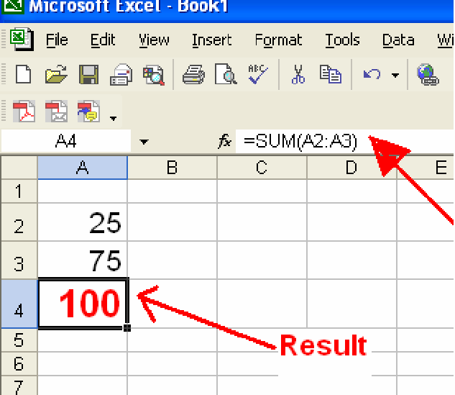

Question No: 16 ( Marks: 1 ) - Please choose one
VisiCalc was the first popular _ application on PC’s.

_ Spreadsheet Page 151
_ Word processor
_ Presentation
_ Database
Question No: 17 ( Marks: 1 ) - Please choose one
is a system software that converts the source code written in high level language
into machine language code.
_ Utilities
_ Drivers

_ Language Translator Page 59
_ None of the these
Question No: 18 ( Marks: 1 ) - Please choose one
What happens if I start a new list without closing the original one?
_ An error will be generated

_ A nested list will be created Page 52
_ Previous list will end and a new will start.

_ Nothing will happen
Question No: 19 ( Marks: 1 ) - Please choose one
is a program that executes instructions line by line written in a high-level language.

_ Interpreter Page 130, 131
_ Compiler
_ Predictor
_ Executor
Question No: 20 ( Marks: 1 ) - Please choose one
There are rules to write the Pseudo Code.
_ Standard

_ No standard Page 109.
_ Strict
_ Pre-defined
Question No: 21 ( Marks: 1 ) - Please choose one Which one is not the building block of an algorithm?

_ Statements Page 107
_ Sequences
_ Repetitions
_ Conditionals
Question No: 22 ( Marks: 1 ) - Please choose one
In flow charts, there is only one entry point in conditions while there is/are exit points.
_ 1

_ 2 I think True and False two conditions are found.
_ 3
_ 4
Question No: 23 ( Marks: 1 ) - Please choose one
A procedure that usually but not always works or that gives nearly the right answer is called_
_ Deterministic Algorithm

_ Heuristic Algorithm Page 102
_ Greedy Algorithm
_ Randomized Algorithm
Question No: 24 ( Marks: 1 ) - Please choose one A Modem is a kind of
_ Input device

_ Output device
_ Storage device

_ Input and Output device Page 25
Question No: 25 ( Marks: 1 ) - Please choose one The
memory size of the Altair 8800 was
_ 128 bytes
_ 128 Kilo bytes
_ 256 Kilo bytes

_ 256 bytes Page 15
Question No: 26 ( Marks: 1 ) - Please choose one
---------- was known as “mill” in Analytical engine.
_ Memory

_ Processor
_ Monitor
_ Mouse

MIDTERM EXAMINATION
Spring 2010

CS101- Introduction to Computing

Question No: 1 ( Marks: 1 ) - Please choose one

Vacuum tubes were replaced by

- Punch cards

Transistors Lecture 2

- Micro Processors

- Resistors

Question No: 2 ( Marks: 1 ) - Please choose one

Hexadecimal number system is based on digits

- 2

- 8

- 12

16 Lecture 8

Question No: 3 ( Marks: 1 ) - Please choose one

Java script interact with user through

- Special control

Internet explorer

- Event handlers

- Java script does not interact with user

Question No: 4 ( Marks: 1 ) - Please choose one

Which one is correct for JavaScript?

onMouseOver Lecture 15 (Web development 5)

- OnMouseOver

- onmouseover

- All of the given

Question No: 5 ( Marks: 1 ) - Please choose one

Programs that reside on Web servers and receive info that a user enters in a form, are known as:

Server-Side Scripts page 71 (Repeated)

- Client-Side Scripts

- Super Scripts

- Form Scripts

Question No: 6 ( Marks: 1 ) - Please choose one

The is connected to all other modules of the microprocessor.

Control unit Page 36

- Memory unit

- Floating Point unit

- Arithmetic and Logic unit

Question No: 7 ( Marks: 1 ) - Please choose one

WWW stands for:

- Wide World Web

World Wide Web Page 16 (Repeated)

- World White Web

- World Web Wide

Question No: 8 ( Marks: 1 ) - Please choose one

Supercomputers are used in:

- Weather forecasting

- Aeroplane mnufacturing

- Atomic bomb experiments

All of the given choices Lecture 4

Question No: 9 ( Marks: 1 ) - Please choose one

Which one of these is NOT an example of storage devices?

- Tape

RAM Sure Lecture 4

- Floppy

- DVD

Question No: 10 ( Marks: 1 ) - Please choose one

To display a checkbox on the web page, we use tag

- CHECKBOX

- CHECK

INPUT Page 92

- INPUTBOX

Question No: 11 ( Marks: 1 ) - Please choose one

Users communicate with the computer using a consistent user interface provided by the OS.

True sure

- False

Question No: 12 ( Marks: 1 ) - Please choose one

OO software is all about .

- Behaviors

- Methods

- Properties

Objects

Question No: 13 ( Marks: 1 ) - Please choose one

Web standards are being developed by

- Mozilla

- Microsoft

- IBM

- World Wide Web Consortium

Question No: 14 ( Marks: 1 ) - Please choose one

are great for showing parts of a whole that are generally expressed in percentages.

  - Line Charts

Pie Charts Page 154 Diagram (Repeated)

  - Bar Charts

  - None of the options described

Question No: 15 ( Marks: 1 ) - Please choose one

A diode is a terminal device

- Three

Two page 32

- One

- None of above

Question No: 16 ( Marks: 1 ) - Please choose one

Select the attribute of the <form> tag

- Method

- Action

- Value

All of above <form name=”” method=”” action=”” value=””> </form>

All Solved MCQSMIWDTEiRtMhERXAeMfIeNrATeIOnNcSepsrinIgn20O10ne File.

All Solved MCQS With References In One File.

CS101- Introduction to Computing (Session - 4)

Question No: 1 ( Marks: 1 ) - Please choose one Ada, Countess of Lovelace developed first:
- Computer
- Website

Computer Program Lecture 1
- Analytical engine

Question No: 2 ( Marks: 1 ) - Please choose one Charles Babbage was a/an
- Mathematician Lecture 1
- Computer Scientist
- Physician
- Analyst

Question No: 3 ( Marks: 1 ) - Please choose one
Detailed plan, specifying the required resources and expected deliverables, is done in
phase.

- Planning
- User Requirements
- Design

Developer Specification Page 136 Diagram.

Question No: 4 ( Marks: 1 ) - Please choose one
A computer program that facilitates the communication between the computer and a peripheral device is called

Operating system Sure
- Utilities

►ALlalngSuaogelvTreandslaMtorCQS With References In One File.
- Device Drives

Question No: 5 ( Marks: 1 ) - Please choose one

To start an ordered list from 20 instead of 1, we will write

- <OL begin = “20">
- <OL initiate = “20">

<OL start = “20"> page 53
- <OL from = “20">

Question No: 6 ( Marks: 1 ) - Please choose one
is the best known builder for supercomputers.

- Sun

Cray Research p a g e 21
- Microsoft
- Apple

Question No: 7 ( Marks: 1 ) - Please choose one
Using COLSPAN, number of rows of the current cell should extend itself
- Upward

Downward Page 56
- Both Upward and Downward
- None of the given choices

Question No: 8 ( Marks: 1 ) - Please choose one
Interactive forms are always placed

between
- TITLE
- HEAD

BODY
- HTML

Question No: 10 ( Marks: 1 ) - Please choose one
Speakers fall into the hardware category.

True
- False

Question No: 11 ( Marks: 1 ) - Please choose one
software directly
interacts with the hardware.

- Application software

System software page 60
  - Dynamic software

  - Distributed software

Tag set

Question No: 13 ( Marks: 1 ) - Please choose one
is known as the best feature in word processing.
- Cut
- Copy
- Paste

Undo because by using undo we can recover our mistakes and do experiments without risks.

Question No: 14 ( Marks: 1 ) - Please choose one
In java script objects may have properties.
- Single

- Several

- Multiple

All of the given options

Question No: 14 ( Marks: 1 ) - Please choose one
In java script objects may have properties.
- Single

- Several

- Multiple
- All of the given options

Question No: 15 ( Marks: 1 ) - Please choose one
are great for showing parts of a whole that are generally expressed in percentages.

  - Line Charts

Pie Charts page 154 repeated

- Bar Charts

- None of the options described

Question No: 16 ( Marks: 1 ) - Please choose one
Small Computer System Interface is
- Slower and harder to configure then serial and parallel ports

- Faster then USB
- Both first choices

Slower then USB but Faster then serial and parallel page24

MIDTERM EXAMINATION

Spring 2010
CS101- Introduction to Computing

Question No: 1 ( Marks: 1 ) - Please choose one

Vacuum tubes were replaced by

- Punch cards

Transistors Repeated

- Micro Processors

- Resistors

Question No: 2 ( Marks: 1 ) - Please choose one

Hexadecimal number system is based on digits

- 2

- 8

- 12

- 16 Lecture 8

Question No: 3 ( Marks: 1 ) - Please choose one

Java script interact with user through

- Special control

Internet explorer Repeated

- Event handlers

- Java script does not interact with user

Question No: 4 ( Marks: 1 ) - Please choose one

Which one is correct for JavaScript?

onMouseOver Repeated

- OnMouseOver

- onmouseover

- All of the given

Question No: 5 ( Marks: 1 ) - Please choose one

Programs that reside on Web servers and receive info that a user enters in a form, are known as:

Server-Side Scripts Repeated

- Client-Side Scripts

- Super Scripts

- Form Scripts

Question No: 6 ( Marks: 1 ) - Please choose one

The is connected to all other modules of the microprocessor.

Control unit Repeated

- Memory unit

- Floating Point unit

- Arithmetic and Logic unit

Question No: 7 ( Marks: 1 ) - Please choose one

WWW stands for:

- Wide World Web

World Wide Web Repeated

- World White Web

- World Web Wide

Question No: 8 ( Marks: 1 ) - Please choose one

Supercomputers are used in:

- Weather forecasting

- Aeroplane mnufacturing

- Atomic bomb experiments

All of the given choices Lecture 4

Question No: 9 ( Marks: 1 ) - Please choose one

Which one of these is NOT an example of storage devices?
- Tape

RAM Repeated

- Floppy

- DVD

Question No: 10 ( Marks: 1 ) - Please choose one

To display a checkbox on the web page, we use tag

- CHECKBOX

- CHECK

INPUT
- INPUTBOX

MIDTERM EXAMINATION
Spring 2010

CS101- Introduction to Computing

QuestioAn Nllo:S1 o( Mlvareksd: 1M) - CPleQasSe cWhooistehonRe

eferences In One File.

Cray-1 was first commercial computer

- Super Repeated Lecture 4 (Topic Super Computer)

- Mini

- Micro

- Personal

Question No: 2 ( Marks: 1 ) - Please choose one

language is very good for writing well-structured and readable programs, but it is not as flexible as the C programming language

- BASIC

PASCAL page 131

- JAVA

- FORTRAN

Pascal is verygood for writing well-structured and readable programs, but it is not as flexible as the C programming language

Question No: 3 ( Marks: 1 ) - Please choose one

What happens if I start a new list without closing the original one?

- An error will be generated

- A nested list will be created Repeated

- Previous list will end and a new will start.

- Nothing will happen

Question No: 4 ( Marks: 1 ) - Please choose
one

A computer program that facilitates the communication between the computer and a peripheral device is called

Operating system Repeated

- Utilities

- Language Translator

- Device Drives

Question No: 5 ( Marks: 1 ) - Please choose one

AutoCAD falls in the category of

Engineering Applications page 61

- Graphics Applications

- Scientific Applications

- Business Applications

Question No: 6 ( Marks: 1 ) - Please choose one

Tag used to make a Text Bold is

- <BOLD></BOLD>

<B></B> sure

- <BODY></BODY>

- None of these

Question No: 7 ( Marks: 1 ) - Please choose one

Which one of these is NOT an example of embedded computers?

IMB PC

- Microwave oven

- Refrigerator

- Calculator

Question No: 8 ( Marks: 1 ) - Please choose one

Supercomputers are used in:

- Weather forecasting

- Aeroplane manufacturing

- Atomic bomb experiments

All of the given choices Repeated

Question No: 9 ( Marks: 1 ) - Please choose one

Which one of these is NOT an example of storage devices?

- Tape

RAM Repeated

- Floppy

- DVD

Question No: 10 ( Marks: 1 ) - Please choose one

In which case Cache Memory is used

  - To increase RAM speed

  - To overcome BUS speed

To overcome Speed rate between RAM and CPU Not sure

- To overcome CPU speed

Question No: 11 ( Marks: 1 ) - Please choose one

A set ofAsltalnSd oalolvneepdroMducCtivQitySapWpliciatthionRs deefseigrneedntcoewsorIkntogOetnheer kFnoiwlen.as

.

Productivity software suites page 84

- Compiled software

- Secure software

- Intelligent software

Question No: 12 ( Marks: 1 ) - Please choose one

File handling in java script is done .

- In more accurate way

- In more easy way

- Both more easy and in accurate way

Not at all

Question No: 13 ( Marks: 1 ) - Please choose one

Which one of the following is a valid variable name?

- Break

- Switch

- Catch

None of the given Lecture 21

Question No: 14 ( Marks: 1 ) - Please choose one

An algorithm that always takes the best immediate or local solution while finding an answer is called

- Deterministic Algorithm

- Non deterministic Algorithm

Greedy Algorithm Page 102

- Randomized Algorithm

Question No: 15 ( Marks: 1 ) - Please choose one

A | B | C | D
4 | ABC003 | 65 | =c4=c4

Expression format in cell D4 is NOT correct.

True According to Ms-Excel

- False

QuestiAonllNSo:o1l6v(eMdarMks:C1Q) -SPlWeasiethchoRoesefeorneences In One File.

User interface provided by UNIX operating system is:

- Shell / GUI page 68
- Shell

  - GUI
  - Command line

MIDTERM EXAMINATION Spring 2010
CS101- Introduction to Computing (Session - 5)

Question No: 1 ( Marks: 1 ) - Please choose one
language is very good for writing well-structured and readable programs, but it is not as flexible as the C programming language

    - BASIC

PASCAL Page 131
- JAVA
- FORTRAN

Question No: 2 ( Marks: 1 ) - Please choose one

interacts directly with the computer Hardware

- Compiler

Operating system Repeated

- Application software

- Assembler

Question No: 3 ( Marks: 1 ) - Please choose one
If type attribute of INPUT tag is set to "reset", then it will:

- Save all the data
- Set the shape of all the fields

- Set all fields to their default valuesfSeurree nces In One File.
All Solved MCQS With Re

All Solved MCQS With References In One File.

- Do nothing, you have to write code for it

Question No: 4 ( Marks: 1 ) - Please choose one

Programs that reside on Web servers and receive info that a user enters in a form, are known as:

Server-Side Scripts Page 71 (Repeated)

- Client-Side Scripts

- Super Scripts

- Form Scripts

Question No: 5 ( Marks: 1 ) - Please choose one

The world first computer program was written to compute:
- Simple sequence
- Multiple sequence

Bernoulli’s sequence page 9
- Increasing sequence

Question No: 6 ( Marks: 1 ) - Please choose one

The key strengths of computers are
- Speed
- Storage
- Do not get bored

All of the given choices Sure

Question No: 7 ( Marks: 1 ) - Please choose one
is the interface in computer that supports transmission of multiple

bits atAthlelsSamoelvtimede. MCQS With References In One File.

- Serial Port

Parallel Port page 24
- Universal Serial Bus
- None of the given choices

Question No: 8 ( Marks: 1 ) - Please choose one

Which of the following is NOT supported by PC's power supply.
- -12 and +12 V DC

-10 and +10 V DC
- -5 and + 5 V DC
- All are supported

Question No: 9 ( Marks: 1 ) - Please choose one

NOWRAP extends of a cell, if necessary, to fit the contents of the cell the in a single line
- Height
- Length

Width page 56
- Value

Question No: 10 ( Marks: 1 ) - Please choose one

We need for memory management in computer
- Software
- Hardware

Operating System OS is used for memory management. From Handouts.
- Application Software

Question No: 11 ( Marks: 1 ) - Please choose one

The first component of an operating system that runs when a typical computer is turned
ON, is:

- Device Manager
- File Manager
- Loader
- Device Driver

Question No: 12 ( Marks: 1 ) - Please choose one

Speakers fall into the hardware category.

True
- False

Question No: 13 ( Marks: 1 ) - Please choose one

HTML pages are edited by
- MS Front page
- Notepad
- Dream weaver

All of These (These all are Code Editors.)

Question No: 14 ( Marks: 1 ) - Please choose one
PowerBuilder falls in the category of .

- Assembly Languages
- 4-th Generation Languages
- Machine Languages

High-Level Languages

Question No: 15 ( Marks: 1 ) - Please choose one
Java script is an.
- Object based language

All of the given page 96

- Interpreted language

- Event driven language

Question No: 16 ( Marks: 1 ) - Please choose one

In java script objects may have properties.
- Single

- Several

- Multiple

All of the given options Repeated

MIDTERM EXAMINATION Spring 2010

CS101- Introduction to Computing (Session - 4)

Question No: 1 ( Marks: 1 ) - Please choose one

JavaScript does not support

- User interaction
- Graphics

Network operations Page 120
- Both Graphics and Network operations

Question No: 2 ( Marks: 1 ) - Please choose one

Language is very good for writing well-structured and readable programs, but it is not as flexible as the C programming language
- BASIC

PASCAL Repeated
- JAVA
- FORTRAN

Question No: 3 ( Marks: 1 ) - Please choose one

is the example of Shrink-wrapped software

- PIA information system
- WinZip trial pack
- Linux

MS Word Page 62

Question No: 4 ( Marks: 1 ) - Please choose one

refers to the firmware code which is run by an IBM compatible PC when

powered
on.
first

- DOS

BIOS page 61
- Utility Program
- None of these

Question No: 5 ( Marks: 1 ) - Please choose one

RTOS stands for

- RAealllTSasok OlvpeeradtinMg SyCstQemS With References In One File.

- Random Time Operating System
- Rational Time Operating System

Real Time Operating System p a g e 67

Question No: 6 ( Marks: 1 ) - Please choose one

-------- is an electronic path within a Computer System along which bits are transmitted.

- Port
- Slots

Bus Not sure
- Modem

Question No: 7 ( Marks: 1 ) - Please choose one
A microprocessor can be made more powerful by increasing its

- Clock frequency
- Word length

Clock frequency and Word length p a g e 318
- None of above

Question No: 8 ( Marks: 1 ) - Please choose one

Which one of these translates the program once at a time ?
- Interpreter

Compiler page 61
- Operating system
- Translator

Question No: 9 ( Marks: 1 ) - Please choose one

------- is volatile memory

page 25
- RAM

Disk ROM

Question No: 10 ( Marks: 1 ) - Please choose one
A British scientist named John A. Fleming made a vacuum tube known today as a diode. Then the diode was known as a "valve," Is it true?

page 14
- true

Question No: 11 ( Marks: 1 ) - Please choose one

<form> Tags always placed between the <BODY> and </BODY> tags of a Web page

►True


Question No: 12 ( Marks: 1 ) - Please choose one

is generally measured in terms of the number of steps required to

algorithm
.
execute an

- Space

Time page 101
- Memory and time
- Bandwidth

Question No: 13 ( Marks: 1 ) - Please choose one

Programs where no user interaction found during program execution are called .

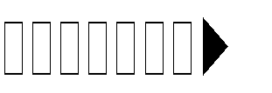Batch programs page 129
-driven programs based programs
None of the given

Question No: 14 ( Marks: 1 ) - Please choose one
For connector the following symbol is used:





Circle Page 105

Question No: 15 ( Marks: 1 ) - Please choose one

After starting computer, which module of operating system activates first?





  - Kernel Not sure but it is the heart of OS.

manager

Question No: 16 ( Marks: 1 ) - Please choose one

"Every minute dies a man, And one and a sixteenth is born" said by?

Lord Tennyson


Charles Babbage during Video lecture


Countess of Lovelace


and Lord Tennyson

MID TERM PAPERS
Question No: 1 ( Marks: 1 ) - Please choose one Human are better than computers at:
- Efficiency
- Accuracy

Pattern recognition SURE
- None of the given choices

Question No: 2 ( Marks: 1 ) - Please choose one

Cray-1 was first commercial computer

Super Repeated

- Mini
- Micro
- Personal

Question No: 3 ( Marks: 1 ) - Please choose one URL is a/an
- Device
- Component

Address Repeated
- Tool

Question No: 4 ( Marks: 1 ) - Please choose one Mainframe Computers are also called
- Enterprise Servers
- Personal Servers
- Enterprise Managers
- Window Servers http://www.skullbox.net/mfservers.php

Question No: 5 ( Marks: 1 ) - Please choose one

Which of the following is NOT a category of Mobile Computers?
- Laptop
- Palmtop

Desktop sure
- Wearable

Question No: 6 ( Marks: 1 ) - Please choose one

Preliminary exploration of possible solutions, technologies, suppliers is called

- Viability

Feasibility Page 135
- Specification
- Integration

Question No: 7 ( Marks: 1 ) - Please choose one

Give us the ability to manipulate data through reference instead of actual value.
- Constants

Variables Page 143
- Data Types
- Operators

Question No: 8 ( Marks: 1 ) - Please choose one

Consider the following statement written in JavaScript: str = ”Hello” + ” World”
What will be the value of str ?

HelloWorld document. write(“Hello”+”World); In this HelloWorld is string.
- Hello World
- Hello + World
- It will result in error

Question No: 9 ( Marks: 1 ) - Please choose one
A tool that helps you to find the synonyms is called .

- Language
- Paragraph

Thesaurus From handouts.
- Symbol

Communication protocol is a that governs the flow of information over a network
- Set of protocols

Set of rules
- Device
- Set of methods

Question No: 11 ( Marks: 1 ) - Please choose one

computer could pass the Turing test then it would be able to:

think like human beings
- do the things faster
- win a million dollar prize
- store more information

If a

Question No: 12 ( Marks: 1 ) - Please choose one
The first Web browser with a GUI was generally available in:
- 1992

1993 Page 209
- 1994
- 1995

Question No: 13 ( Marks: 1 ) - Please choose one

Web is a unique invention by humans in terms that it is:
- accessible to only the owners who control it
- accessible from particular locations only

accessible to all humans sure
- accessible to only the educational institutes

Question No: 14 ( Marks: 1 ) - Please choose one
In this URL http://www.msn.com , identifies the domain name
- http
- www

msn
- com

Question No: 15 ( Marks: 1 ) - Please choose one

is simply a fast port that lets you connect computer peripherals and consumer electronics to your computer without restart.

- Freeware
- Shareware

Firewire Page 24
- Firmware

Question No: 16 ( Marks: 1 ) - Please choose one

Which of the following is NOT supported by PC's power supply.
- -12 and +12 V DC

-10 and +10 V DC Repeated

- -5 and + 5 V DC
- All are supported

Question No: 17 ( Marks: 1 ) - Please choose one
In

which case Cache Memory is used
- To increase RAM speed
- To overcome BUS speed

To overcome Speed rate between RAM and CPU Repeated
- To overcome CPU speed

Question No: 18 ( Marks: 1 ) - Please choose one
To display a single line text area on the web page, we use tag
- TEXT
- TEXTBOX

INPUT <input type=”text” name=”text” size=”30”>
- INPUTBOX

Question No: 19 ( Marks: 1 ) - Please choose one
If an algorithm is syntactically correct, but semantically incorrect then this situation is
- Very good situation

Very dangerous situation From handouts Page 104
- Not very bad
- Neutral situation

Question No: 20 ( Marks: 1 ) - Please choose one

Users communicate with the computer using a consistent user interface provided by the OS.
►True
  - False

Question No: 21 ( Marks: 1 ) - Please choose one

Application developers do not need to know much about the HW, especially the microProcessor, while they are developing their application.

True
- False

Question No: 22 ( Marks: 1 ) - Please choose one
The first spread sheet program was invented by
- Charles Babbage

Dan Bricklin
- Paul Graham
- John von Neumann

Question No: 23 ( Marks: 1 ) - Please choose one

Which representation technique of algorithm is more suitable for developer to make actual code .

pseudo code Pseudo code is like actual code. For example: Pseudo code is : if(condition){Code embedded}
- flow chart
- both pseudo code and flow chart
- Heuristics

Question No: 24 ( Marks: 1 ) - Please choose one

is used to terminate all JavaScript statements.
- Colon

Semicolon Lecture 21
- Underscore
- Apostrophe

Question No: 25 ( Marks: 1 ) - Please choose one
In java script cookies can be created for future use .

- Easily

- No facility at all

- This is not possible without Java language.

Cookies are files so java script can not handle it.

Question No: 26 ( Marks: 1 ) - Please choose one
72

When the microprocessor desires to look at a piece of data, it checks in the
  - RAM
  - ROM
  - hard disk

cache

MIDTERM EXAMINATION Fall 2009

CS101- Introduction to Computing (Session - 5)

Question No: 1 ( Marks: 1 ) - Please choose one The memory size of the Altair 8800 was
- 128 bytes
- 128 Kilo bytes
- 256 Kilo bytes

256 bytes Repeated

Question No: 2 ( Marks: 1 ) - Please choose one URL is a/an
- Device
- Component

Address Repeated
- Tool

Question No: 3 ( Marks: 1 ) - Please choose one Which of the following hardware component of a computer can also be called as engine?
- Bus
- Storage
- Memory

Processor

Question No: 4 ( Marks: 1 ) - Please choose one The Processor is specially designed for PDA?
- PowerPC

StrongARM Page 24
- Crusoe
- SPARC

Question No: 5 ( Marks: 1 ) - Please choose one
There are ways to represent an algorithm.

►A1ll Solved MCQS With References In One File.

►2

3 Greedy, Deterministic and Randomized.
►4

Question No: 6 ( Marks: 1 ) - Please choose one
Which one is correct for JavaScript?

onMouseOver Repeated
- OnMouseOver
- onmouseover

- All of the given

Question No: 7 ( Marks: 1 ) - Please choose one
is a particularly good language for processing numerical data, but it does not lend itself very well to large business programs

- BASIC
- PASCAL
- JAVA

FORTRAN page 131

Question No: 8 ( Marks: 1 ) - Please choose one
In spreadsheets, cell address A12 means .

- Row A, Cloumn 12

Row 12, Cloumn A
- Row 2,Cloumn A1
- Row A1, Cloumn 2

Question No: 9 ( Marks: 1 ) - Please choose one
The key feature of Scientific/Engineering/Graphics applications is

Intense calculations page 81

- User-friendly

- Reliability

- Cost-effective

Question No: 10 ( Marks: 1 ) - Please choose one
Command which saves the selected text before deleting is

Copy

- Delete

- Cut

- Undo

Question No: 11 ( Marks: 1 ) - Please choose one
Properties of an object are modified with

- Class

Methods page 142

- Structures

- Forms

Question No: 12 ( Marks: 1 ) - Please choose one
Video Card has its own -----------------

- Memory
- Processor

Memory& Processor From topic Entertainment Soft wares
- Neither memory nor Processor

Question No: 13 ( Marks: 1 ) - Please choose one
Using only HTML we can create

- Dynamic web pages

Static web pages Repeated

- Both Static and Dynamic pages

- None of these

Question No: 14 ( Marks: 1 ) - Please choose one
Computers are good at
- Speed
- Storage
- Never bored

All of the given choices Repeated

Question No: 15 ( Marks: 1 ) - Please choose one
There is a battery on the motherboard to:
- Give power to the processor

Save information when computer is off
- Save information when computer is on

Give power to the motherboard

Question No: 16 ( Marks: 1 ) - Please choose one
Microsoft Word is a type of:
- System Software

- Freeware Software

Shrink-Wrapped Software page 62
- Custom-built Software

Question No: 17 ( Marks: 1 ) - Please choose one
The set of instructions that opearates various parts of hardware is called shareware.
- True

False Share ware is the type of soft ware.

Question No: 18 ( Marks: 1 ) - Please choose one
Which of the following manages the HW and SW resources of the computer system?
- Hardware
- System Software

Operating system page 65
- Graphics Software

Question No: 19 ( Marks: 1 ) - Please choose one
Application developers do not need to know much about the HW, especially the microProcessor, while they are developing their application.

True Repeated
- False

Question No: 20 ( Marks: 1 ) - Please choose one
Which of the following formula is used in spread sheet for addition?

- C6+E6

► =C6+E6 Lecture 22 Diagram.
- 6+6=12
- 6+E6

Question No: 21 ( Marks: 1 ) - Please choose one
Web Pages developed for human as well computer understanding are called as;
- Static Web Pages

- Semantic Web PagesS With References In One File.
All Solved MCQ

- Dynamic Web Pages
- Java Web Pages

Question No: 22 ( Marks: 1 ) - Please choose one
Programs where no user interaction found during program execution are called
.

Batch program p a g e 129
- Event-driven programs
- Graphics based programs
- None of the given

Question No: 23 ( Marks: 1 ) - Please choose one
In , the software developer decomposes the problem into subsystems and defines their relationships.

- Detailed Design
- Integration Testing
- Design page 137
- Architecture

Question No: 25 ( Marks: 1 ) - Please choose one
What is the key feature of computer which is against human nature?

Can’t get bored.
- Pattern recognition
- Repetition
- None

Question No: 26 ( Marks: 1 ) - Please choose one
The first was invented at Bell Laboratories on December 16, 1947 by William
Shockley.

Transistor page 14

- Vacuum Tube

- Punch card

- Transmitter

All Solved MMCiQdSTeWrmithExRaemfeinraetniocness In One File.

Fall 2009

Question No: 1 ( Marks: 1 ) - Please choose one
A diode functions as the electronic version of a _-way valve.

one Diode is device which allows the current only in one way.
- two
- three
- four

Question No: 2 ( Marks: 1 ) - Please choose one
What is name of book from which word algorithm is taken ?

  - Algebra and trigonometry

  - Introduction to algorithms

  - Research for new horizons

Algoritmi de numero Indorum Lecture 16

Question No: 3 ( Marks: 1 ) - Please choose one
<form> Tags always placed between the <BODY> and </BODY> tags of a Web page

True Repeated
- False

Question No: 4 ( Marks: 1 ) - Please choose one
consists of cells arranged in rows & columns

Spreadsheets Software Repeated
- Word processor
- Presentation Software
- Microsoft Paint Software

Question No: 5 ( Marks: 1 ) - Please choose one

was designed as a replacement for typewriter
- Spreadsheet Software

Word Processor Software Lecture 14 (Repeated)
- Presentation Software
- Database Software

Question No: 6 ( Marks: 1 ) - Please choose one
manages the HW and SW resources ( memory, disk drives etc) of the computer system, often invisibly.
- Explorer.exe
- System Files

Operating System Repeated

- Application Software

Question No: 7 ( Marks: 1 ) - Please choose one
To display a radio button on the web page, we use tag
- INPUTBUTTON

INPUT <Input type=”radio” name=”from” value=””>
- RADIOBUTTON
- RADIO

Question No: 8 ( Marks: 1 ) - Please choose one
Machine language is also called

Assembly Language Repeated
- Binary Language
- High Level Language
- HTML Language

Question No: 9 ( Marks: 1 ) - Please choose one When the user needs something to be done by the computer, he/she gives instructions in the form of
to computer
- Software, Hardware
- Hardware, Software

System Software, Application Software
- Graph, Monitor

Question No: 10 ( Marks: 1 ) - Please choose one
A truth table defines the of a logic function for all possible

Input – Outputs Lecture 8
- Output -- Inputs
- Process -- Inputs
- Input -- Processes

Question No: 11 ( Marks: 1 ) - Please choose one
Which one is correct?

►A<BlOl DSYo><l/vBOeDdY>MCQS With References In One File.

- <body></body>

Both <BODY></BODY> and <body></body>
- <BODY/>

Question No: 12 ( Marks: 1 ) - Please choose one
WWW stands for:
- Wide World Web

World Wide Web Repeated
- World White Web
- World Web Wide

Question No: 13 ( Marks: 1 ) - Please choose one
A translates a high-level language (that is easy to understand for humans) into a language that the computer can understand
- Computer
- Transistor

Compiler page 61
- Device

Question No: 14 ( Marks: 1 ) - Please choose one
Deep Blue was the name of

computer
- human
- city
- game

Question No: 15 ( Marks: 1 ) - Please choose one
Data travels through bus in the form of ---------------------------

- Packets
- Bits

Bytes Out of 22 Lectures
- Word

Question No: 16 ( Marks: 1 ) - Please choose one
Command which saves the selected text before deleting is

Copy Repeated

- Delete

- Cut

- Undo

QuestAiolnlNSoo: 1lv7 ed( MMarkCsQ: 1S) W- PitlehasRe cehfoeorseenoncees In One File.
AutoCAD falls in the category of

► Engineering Applications Repeated

  - Graphics Applications

  - Scientific Applications

  - Business Applications

Question No: 18 ( Marks: 1 ) - Please choose one
In Spreadsheets, you can create a relationship between two cells by using .

- Numbers
- Text

Formulas Lecture 22
- None of the given choices

Question No: 19 ( Marks: 1 ) - Please choose one
Which of the following symbol is used for multiple line comments in JavaScript?

- /
- //

/* Lecture 21
- //*

Question No: 20 ( Marks: 1 ) - Please choose one
is a system software that converts the source code written in high level language into machine language code.
- Utilities
- Drivers

Language Translator Repeated
- None of the these

Question No: 21 ( Marks: 1 ) - Please choose one
is a particularly good language for processing numerical data, but it does not lend itself very well to large business programs

- BASIC
- PASCAL
- JAVA

FORTRAN page 131

Question No: 22 ( Marks: 1 ) - Please choose one

WhichAolflthSeofollvloweidngMnuCmbQerSsyWsteimthis uRseedfebyrmeincrcopersocIenssoOr?ne File.

All Solved MCQS With References In One File.

Binary Lecture 8
- Decimal
- Octal
- Hexadecimal

Question No: 23 ( Marks: 1 ) - Please choose one The Processor is specially designed for PDA?
- PowerPC

► StrongARM page 24
- Crusoe
- SPARC

MIDTERM EXAMINATION Spring 2010
CS101- Introduction to Computing (Session - 2)

Question No: 1 ( Marks: 1 ) - Please choose one
Detailed plan, specifying the required resources and expected deliverables, is done in
phase.

  - Planning
  - User Requirements
  - Design

Developer Specification Page 136 (Repeated)

Question No: 2 ( Marks: 1 ) - Please choose one
A combination of word processing and graphic design is

- Corel Draw

Desktop Publishing page 83

- Paint

►AWllorSdPoadlved MCQS With References In One File.

Question No: 3 ( Marks: 1 ) - Please choose one
------------- is an electronic path within a Computer System along which bits are transmitted.

- Port
- Slots

Bus Not sure
- Modem

Question No: 4 ( Marks: 1 ) - Please choose one
The key strengths of computers are
- Speed
- Storage
- Do not get bored

All of the given choices Repeated

Question No: 5 ( Marks: 1 ) - Please choose one
We can change the background color in HTML, using attribute of <body>

- background

bgcolor For example: <body bgcolor=”red”></body>

- backcolor

- backgroundcolor

Question No: 6 ( Marks: 1 ) - Please choose one
ASCII WHITE is the fastest Super computer which can perform calculations in one second.
- 1.3 billion

1.3 trillion
- 1.3 miillion
- 1.3 thousand

Question No: 7 ( Marks: 1 ) - Please choose one
is the example of server-side scripts on Unix servers.
- ASP

CGI page 71 On Unix is CGI and on windows is ASP.
- VBScript
- JavaScript

Question No: 8 ( Marks: 1 ) - Please choose one
We need for memory management in computer
- Software
- Hardware

Operating System OS is used for memory management, Device driver management etc.
- Application Software

Question No: 9 ( Marks: 1 ) - Please choose one
Data was stored and counted mechanically using ------------decimal storage wheels,

--------------- rotary dial switches.

- 300,400

- 1300,1400

►A30l1l0S0,o14l1v00ed MCQS With References In One File.

3000 , 1400 page 14

Question No: 10 ( Marks: 1 ) - Please choose one
The first spread sheet program was invented by
- Charles Babbage

Dan Bricklin Repeated
- Paul Graham
- John von Neumann

Question No: 11 ( Marks: 1 ) - Please choose one
In x = x + 20, x is called a .

- Constant
- String

Variable
- Number

Question No: 12 ( Marks: 1 ) - Please choose one
The transistor is a solid state semiconductor device used for amplification and switching, and has terminals.
two

three page32
four one

Question No: 13 ( Marks: 1 ) - Please choose one
A diode functions as the electronic version of a _-way valve.

one page 32
- two
- three
- four

Question No: 14 ( Marks: 1 ) - Please choose one
This element of Flow Chart is called .
- Process

Off page connector Page 105
- Decision
- Connector

Question No: 15 ( Marks: 1 ) - Please choose one Choose the correct html format to create a checkbox.

- <checkbox>

<input type=”checkbox”>

- <check>
- <input type=”check”>

Question No: 16 ( Marks: 1 ) - Please choose one
---------------is the process of starting or restarting a computer.

►BIOS


►Refreshing


►Booting

None of given

MIDTERM EXAMINATION Spring 2010

CS101- Introduction to Computing (Session - 4)

Question No: 1 ( Marks: 1 ) - Please choose one Ada, Countess of Lovelace developed first:
- Computer
- Website

Computer Program Lecture 1
- Analytical engine

Question No: 2 ( Marks: 1 ) - Please choose one Charles Babbage was a/an
- Mathematician Lecture 1
- Computer Scientist
- Physician
- Analyst

Question No: 3 ( Marks: 1 ) - Please choose one
Detailed plan, specifying the required resources and expected deliverables, is done in
phase.

- Planning

►AUlslerSRoeqluvireemdenMts CQS With References In One File.
- Design

Developer Specification Repeated

Question No: 4 ( Marks: 1 ) - Please choose one
A computer program that facilitates the communication between the computer and a peripheral device is called

- Operating system
- Utilities

Language Translator Repeated
- Device Drives

Question No: 5 ( Marks: 1 ) - Please choose one
To start an ordered list from 20 instead of 1, we will write

- <OL begin = “20">
- <OL initiate = “20">

<OL start = “20"> Lecture 9
- <OL from = “20">

Question No: 6 ( Marks: 1 ) - Please choose one
is the best known builder for supercomputers.

- Sun

Cray Research Repeated
- Microsoft
- Apple

Question No: 7 ( Marks: 1 ) - Please choose one
Using COLSPAN, number of rows of the current cell should extend itself
- Upward

Downward Repeated
- Both Upward and Downward
- None of the given choices

Question No: 8 ( Marks: 1 ) - Please choose one Interactive forms are always placed tag-set between
- TITLE
- HEAD

BODY Repeated
► HTML

Question No: 9 ( Marks: 1 ) - Please choose one
manages the HW and SW resources ( memory, disk drives etc) of the computer system, often invisibly.
- Explorer.exe
- System Files

Operating System Repeated
► Application Software

Question No: 10 ( Marks: 1 ) - Please choose one
Speakers fall into the hardware category.

True Repeated
- False

Question No: 11 ( Marks: 1 ) - Please choose one
software directly interacts with the hardware.

- Application software

System software Repeated

- Dynamic software

- Distributed software

Question No: 12 ( Marks: 1 ) - Please choose one
In spreadsheet, which of the following function is used to solve the

equation
3x
3 − 2 x + 5 = 0

► =COUNTIF
?
► =GoalSeek

None of the above
► =Sum

Question No: 13 ( Marks: 1 ) - Please choose one
is known as the best feature in word processing.
- Cut
- Copy
- Paste

Undo Lecture 14

Question No: 14 ( Marks: 1 ) - Please choose one
In java script objects may have properties.
- Single

- Several

- Multiple

All of the given options

Question No: 15 ( Marks: 1 ) - Please choose one
are great for showing parts of a whole that are generally expressed in percentages.

  - Line Charts

Pie Charts Page 154 Repeated

- Bar Charts

- None of the options described

Question No: 16 ( Marks: 1 ) - Please choose one
Small Computer System Interface is
- Slower and harder to configure then serial and parallel ports

- Faster then USB

Al►l BSoothlfvirset dchoMiceCs

QS With References In One File.

- Slower then USB but Faster then serial and parallel Page 24

All Solved MCQS With References In One File.

